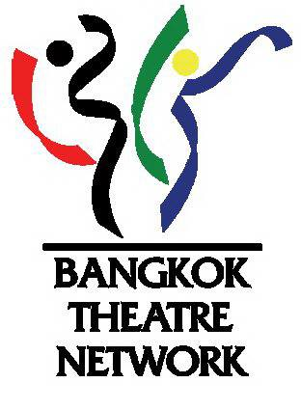
The biggest gathering of Thai Theater artists is back
this November
The 11th Bangkok Theatre Festival
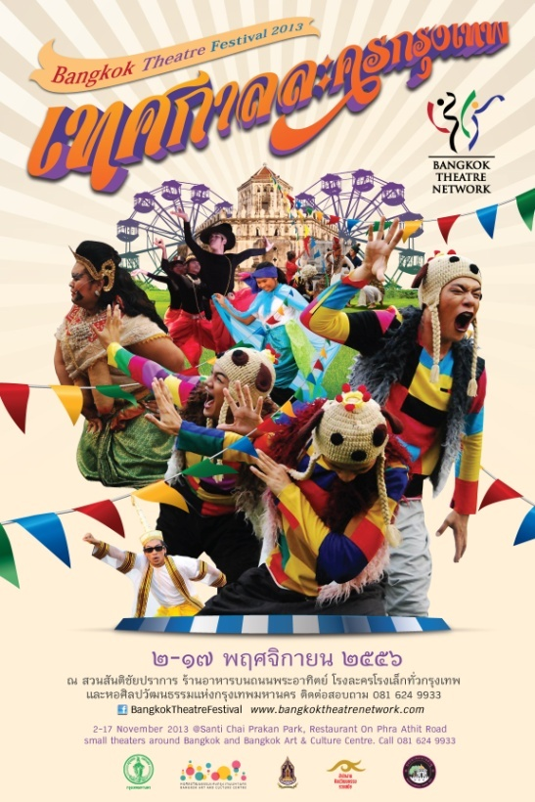

Bangkok Theatre Network (BTN) in collaboration with Banglumphu Community, Office of Contemporary Art and Culture, Ministry of Culture, and Bangkok Art and Culture Center (BACC) presentsthe performing arts festival that Bangkokians have been looking forward to. The 11th Bangkok Theatre Festival, held consecutively for 12 years, is the only festival where the biggest number of theater makers in Thailand come together.
While the UK holds ‘Edinburgh Festival Fringe’ and ‘Festival D’Avignon’ takes place in France as the biggest performing arts destinations attracting travellers from across the globe, Bangkok Theatre Festival is the Thai version that comes closest to them. In Thailand, the theater-going culture began from a tiny circle and grew bit by bit. And in 2002, Bangkok Theatre Festival was held for the very first time.
Over three weekends in November, 2013, indulge yourself in over … performances from nearly 60 performing arts troupes that include professionals, amateurs, and guest artists from abroad. Performances in the festival covers a wide range of style, from traditional Thai performing arts, folk theater, drama, contemporary theater, pantomime, dance, physical theatre, musical theater, experimental theater, theater for children and family, and many more. The performances together with other interesting activities will be held at Santi Chaiprakarn Park, pubs and restaurants in Banglumphu area, Bangkok Art and Culture Center (BACC), and other participating theater spaces across Bangkok in Bangkok Theatre Festival - one of the most richly diverse performing arts festival in Thailand.
The 11th Bangkok Theatre Festival is held for 2 weeks on 2nd – 17th November, 2013. Please visit the festival’s website at www.bangkoktheatrenetwork.comand Facebook Page: Bangkok Theatre Festival,for schedule of performances and news update on the festival. (Performances in the festival are both with and without admission fee. )
___________________________________

About Bangkok Theatre Network (BTN)
Bangkok Theatre Network was founded in 2002 by theater artists, theater professors and teachers in educational institutions, and art-networking groups. Their common mission was to express their standpoint and provide support to one another towards expanding the space for presenting performing arts work to the general public.Members of the network commonly hold the belief in the necessity of a strong and sustainable existence of performing arts in Thailand.
Currently, Bangkok Theatre Network has over 50 members consisting of non-profit professional theater companies, new generation theater troupes, student theater troupes, theater and drama clubs, university theater departments, and independent theater artists.
___________________________________
Significance of Bangkok Theater Festival
1. The only theater festival where the biggest number of theater artists come together and which has been held consecutively for the longest time in Thailand.
2.The birth of Bangkok Theatre Festival 12 years ago significantly created an impact on Thai theatre scene. Apart from helping to conserve and develop the profession of performing arts various disciplines, the festival has nurtured the theater-going culture in Thailand. Every year, more theater troupes participate in the festival, and the range of performance style only gets broader and broader. More theater spaceshave also sprung up across Bangkok with a growing audience.
3.A performing arts festival with the greatest diversity of performing art forms in Thailand, covering traditional performing arts,folk theater, drama, contemporary theater, pantomime, dance, physical theatre, musical theater, experimental theater, theater for children and family, Likay,and many more. It is considered the richest festival in terms of the variety of art forms offered.
___________________________________
Various performing venues and thrilling highlights of this year’s festival:
1. Santi Chayprakarn Park will be transformed into a ‘temple fair,’ incorporating the fun elements and atmosphere of such a fair in the park though decoration, activities, and space management that promises to make you feel as if you’re walking in a real temple fair!
2.Black Box Theatre at ‘Floor 4 Studio’ at Bangkok Art and Culture Center (BACC) will join Bangkok Theatre Festival for the first time, among other partners that have collaborated with the festival continuously for over 12 years, as another venue of performance for the festival. The ‘Floor 4 Studio’ will turn into a Black Box Theatre for selected full-scale theater productions, such as works by award-winning artists, performances that have been invited aboard, new works by Silpathorn artists, and works by veteran theater companies who are regular members the Bangkok Theatre Network.
_______________________________
4 Highlight Performances in Bangkok Theatre Festival 2013
Recommended by Nat Nualpang, Artistic Director of the 2013 Festival
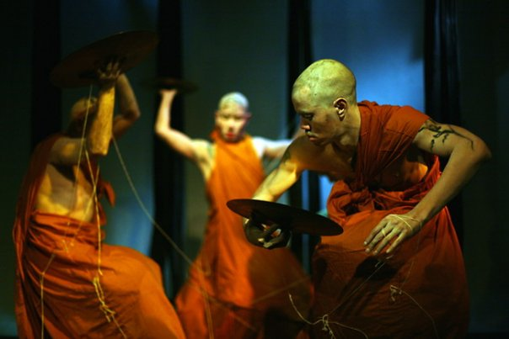
1.San Dan Ka (Nature of the Crow) by B-Floor Theatre
San Dan Ka makes a comeback in the festival after its premiere in 2009. Besides Bangkok Theatre Festival, this Butoh dance performance that used to shake the hearts of Buddhists in Bangkok has been invited to perform in Puebla International Theatre Festival 2013 in Mexico. The performance takes inspiration from the Tripitaka and books of teachings by Buddhadasa Bhikkhu that address evil in disguise of virtue. The concept is conveyed through a dance from called Butoh. Originated in Post-WWII Japan, Butoh rejects all dance conventions be it Western or Eastern, and asks that the dancers move entirely from their emotions and inner feelings. Butoh is also know known as ‘Dance of Darkness’.
At Black Box Studio, Bangkok Art and Culture Center (BACC) on November 13-14, 2013. Duration: 30 minutes.
2. Khon Song Chao (the Medium) by Thai Chamber of Commerce University’s Drama Club
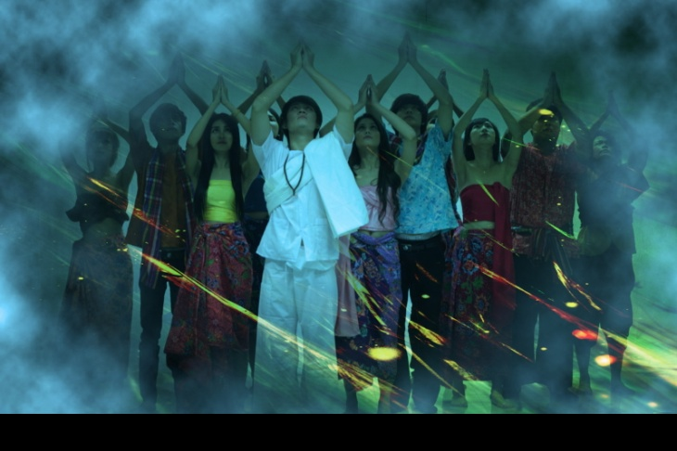
From the famous book by Wimol Sainimnual, ‘Khon Song Chao’ was turned into a famed Thai drama in China and won a major award from a theater festival in Nanning. The moment where Chinese audience all raised their phone cameras to take photos of some scenes in the play reflects the positive feedback the play received tremendously in China. Script and directed by Damkerg Thitapiyasak, an acclaimed theater director and scriptwriter for his expertise in play adaptation.
Venue: Main Stage, Santi Chaiprakarn Park. November 2-3 and 9-10, 2013 at 7-8pm.
3.A-Wa-San Kwan Choey (The End of Staying Still) by Marongdoo
This performance, belonging to a strange-sounding genre of theater, Forum Theatre, will not allow the audience to just sit around but will ask them to get up and join in the show! This Forum Theatre consists of a couple of short plays that grab interesting current social issues and shape them into a story. They hope that the audience will join in ‘untying the knot’ of the plays, as plays are supposed to be played with the world, and playing is simply creating a new world that you want to see happen.
At Grass Lawn Stage, Santi Chaiprakarn Park on November 2, 2013 at 8-9.30pm. And at Riverside Stage on November 9 and 10 at 5.30-7pm.
4.Babymime Show
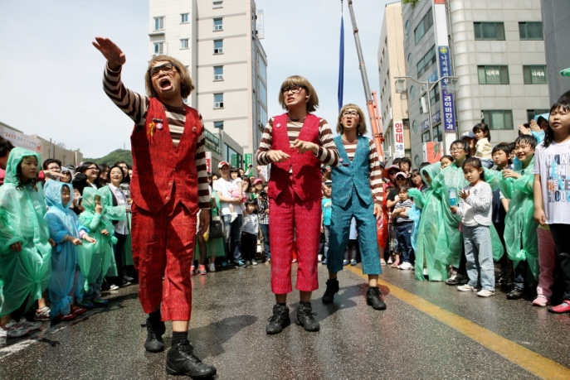
This ever-beloved pantomime group is back in Bangkok Theater Festival again to rock the hearts of the audience like they have done every year. Freshly back from their trips to many Asian countries, they will put their accumulated skills of distributing their unbeatable humor on the stage of Bangkok Theatre Festival. As expected, their performance comes as the long-awaited finale of the festival, and this is becoming a tradition!
Main Stage, Santi Chaiprakarn Park. November 9-10, 2013 at 9.30 – 10pm.
------------------------------------------------------------------------------------------------------------------

